**Statement of Work (4/09/2019)** – Air Control, Air Reach, Smart Glove, Smart Control

**Team “Air Reach”**

**Member 1: Matthew Menendez**

**Member 2: Gregory Siemers**

**Project Objectives or Goals**

* Design and build prototype of subsystem to demonstrate in class
* Perform Engineering Analysis
* List Product and Performance Specifications
* Present in class
* Apply for a patent
* Submit report

**Process used or Approach**

* Develop simplified circuit to test hardware components before creating prototype
* Prototype developed of entire system or sub-system, scaled if necessary to fit the lab capabilities, as well as number of members in a team.
* Each team member is responsible for development, testing and demonstration in class of an independent system /sub-system, or product specification, or performance specification

**Deliverables and Dates**

* See Gannt Chart

**Team Roles & Responsibilities**

Team Member 1-

* Develop Code for Embedded Devices
* Design and Construct Circuit for Components
* Assist in Design and Fabrication of Prototype
* Assist with Documentation and Presentations

Team Member 2-

* Design and Construct Wooden Models
* Perform Engineering Analysis on Subsystem
* Assist in Design and Fabrication of Prototype
* Assist with Documentation and Presentations

**List product or performance specs (target) that would be demonstrated at the end of the semester in class. (Prototype)**

* In Class demonstration of subsystem prototype
  + Prototype glove will allow interaction with model wooden appliances
  + Appliances will “turn on” based on different hand gestures
  + The goal is to have two appliances for the demonstration
  + Team Member 1 and Team Member 2 will be responsible for the development of this demonstration.

**Estimate cost of developing prototype.**

Estimated Cost for Prototype Materials: $150

Arduino Nanos ($15)

HC05 Bluetooth Modules ($9) x2

9V Batteries ($10)

Flex Sensors ($9) x5

Battery Power Source Pack ($9)

Wood ($15)

**Sample CAD Drawing:**

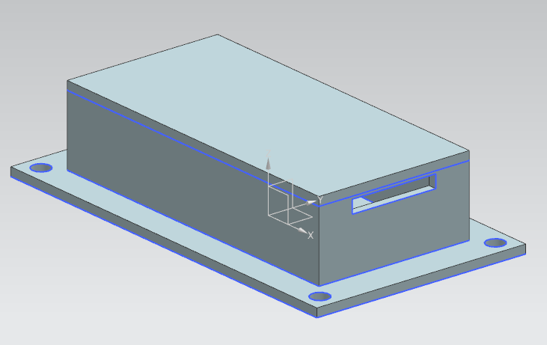

**This is the enclosure for the arduino nano to be mounted on the backside of the glove.**

